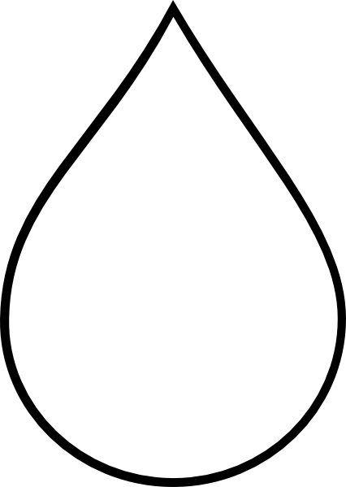
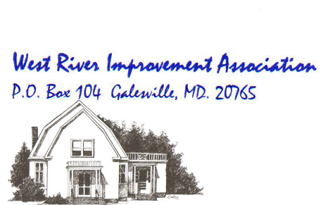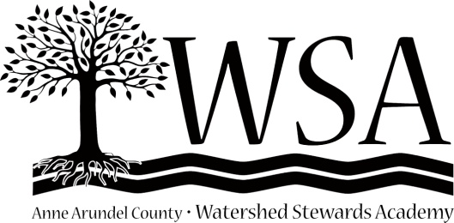

Rain Barrels
For the River

If We All Do a Little,
We Can Do a Lot!
If Galesville residents install 55 rain barrels,
we will prevent over 3,000 gallons of runoff
from polluting the West River.

Arlington Echo Rain Barrels:
Only $30 for 1st 30 Galesville Purchasers
See Reverse for More Information

Rain Barrels
For the River

If We All Do a Little,
We Can Do a Lot!
If Galesville residents install 55 rain barrels,
we will prevent over 3,000 gallons of runoff
from polluting the West River.

Arlington Echo Rain Barrels:
Only $30 for 1st 30 Galesville Purchasers
See Reverse for More Information

Order Arlington Echo Rain Barrels online:

$30 Price Limited to 1st 30 Galesville Resident Orders, One Per Household
$60 Price for All Other Orders

Free Delivery & Installation of Arlington Echo Rain Barrels
for Galesville Residents Only

Contact:

Other Local Rain Barrel Vendors:
[list some here]

For more information about rain barrels and vendors visit: http://www.aawsa.org/solutions/capture-your-stormwater/rainbarrels-and-cisterns.html

Order Arlington Echo Rain Barrels online:

$30 Price Limited to 1st 30 Galesville Resident Orders, One Per Household
$60 Price for All Other Orders

Free Delivery & Installation of Arlington Echo Rain Barrels
for Galesville Residents Only

Contact:

Other Local Rain Barrel Vendors:
[list some here]

For more information about rain barrels and vendors visit: http://www.aawsa.org/solutions/capture-your-stormwater/rainbarrels-and-cisterns.html

