Rain Barrel Vendor List
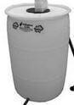  Arlington Echo Outdoor Education Center  Echo Barrel, 55-gallon, white | 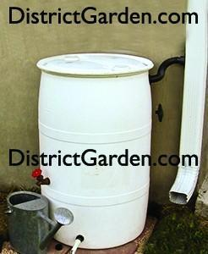  District Garden | 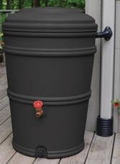  EarthMinded RainStation, 45-gallon, Charcoal | 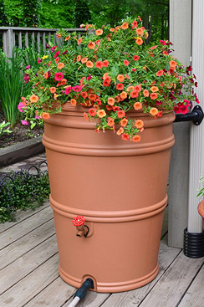  EarthMinded RainStation, 45-gallon, Terracotta | 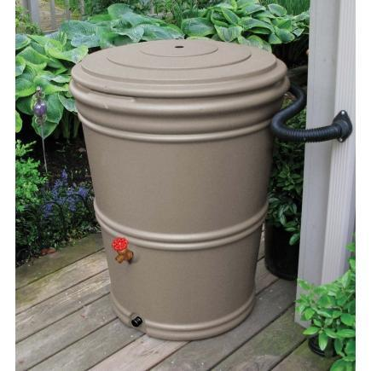  EarthMinded RainStation, 65-gallon, Granite
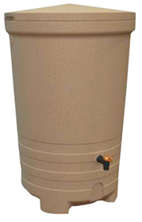Fiskar 58-Gallon, Spice Granite | 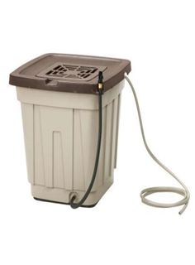Suncast 50-Gallon | 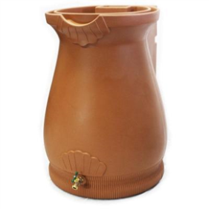  Good Ideas, 65-Gal Rain Wizard Urn, Terracotta | 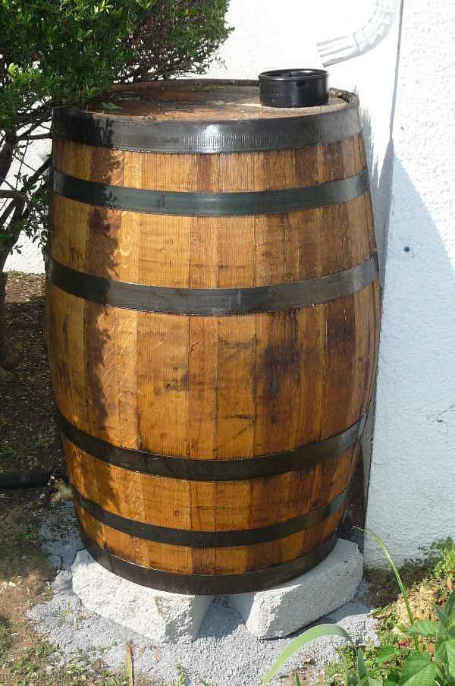  Rain Barrels of Annapolis, 55-Gallon Whisky/Wine Barrel | 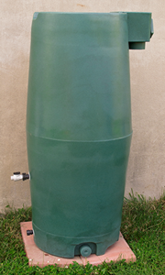  Aquabarrel Abe, 80-gallon
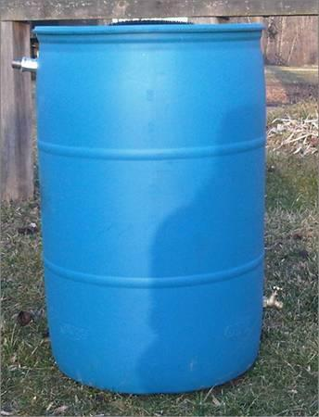
Big blue, 55-gallon

Vendor | Gallons | Manufacturer, Product Descirption | Price | Discount | Install
Ace Hardware | 45 | EarthMinded, Terracotta, Granite, Charcoal | 70
 | 65 | EarthMinded, Granite | 100
 | 48 | Fiskars, Holden | 70
 | 58 | Fiskars, Spice Granite | 140
Anne Arundel Community College  Shad B. Ewart  Rain Barrel Program  sbewart@aacc.edu  410-777-2289 | 55 |  | 70
Aquabarrel  554 North Frederick Avenue  Mail Box #122  Gaithersburg, MD 20877  301-252-8655 | 55 | Aquabarrel, Classic | 99
 | 45 | EarthMinded RainStation – Terracotta, Putty Grey | 79
 | 65 | EarthMinded RainStation, Charcoal, Granite, Moss, Putty Grey, Terracotta | 126
 | 55 | Nino, planter, Blue, green, red, yellow, adobe, grey, black | 245
Arlington Echo Outdoor Education Center  975 Indian Landing Road  Millersville, MD 21108  Lara Mulvaney  410-222-3825 | 50-55 | Echo Barrels, White | $80 | $60
Blue Water Baltimore  3545 Belair Road | Baltimore, MD 21213  410-254-1577 | 60 | DIY White | 51
 | 55 | DIY Blue | 51
 | 60/55 | Upcycled White/Blue | 89
 | 55 | EarthMinded RainStation, Charcoal, Evergreen, Granite, Terracotta | 129
 | 80 | Aquabarrel Abe, Evergreen | 179
Bowen’s Farm Supply  410-224-3340 | 50 | Rain Wizard | 100
 |  | Whiskey Barrel, special order
Bowie Lion’s Club  301-262-2665 | 55 |  | 75
Composters.com
800.233.8438
Deale Hardware and Home Center/Do It Best | 45 | EarthMinded, RainStation, Granite Terracotta | 90
 | 52 | Suncast | 100
 | 60 | Emsco, Rescue Deluxe, Stone | 120
Ciminelli’s EcOasis
18301 Central Avenue
Bowie, MD
301-430-0870
Good Ideas, Savannah Rain Saver | 55 |  | 129
D&P Industries Incorporated (DPI)
503.286.9866
District Garden  2200 Wilson Blvd PMB331 Ste 102  Arlington, VA 22201  info@districtgarden.com | 55 | White, includes diverter, Spigot, Drain Valve, Inflow Vale, Downspout diverter, Hoses and connectionshttp://www.districtgarden.com/product/test-product/#sthash.o7C5hMwY.dpuf | 120 |  | Incl.
 | 55 | White, Blue | 40
 |  | DIY Construction Kit | 30
Gardeners Supply
888.833.1412
GreenTrax
6924 Fort Smallwood Rd
Baltimore, MD 21226
410-439-1085
Friends of the Rappahannock
Home Depot | 50 | Suncast | 85
 | 45 | EarthMinded RainStation, Charcoal Terracotta | 70
 | 60 | WaterUrn, planter | 169
 | 40 | Waterstone | 163
 | 80 | Waterstone | 249
 | 60 | Rescue | 129
 | 65 | Good Ideas, Rain Wizard Urn Terracotta | 119
Homestead Gardens  410-798-5000  Barbara | 55 | Whiskey Barrel | $220
 | 45 | EarthMinded, Rain Station, Recycled Plastic | $190
 | 65 | Algreen, Cascata, terracotta | 280
LID RainSavers  240.463.4044  anne@lidstudio.com  www.lidstudio.com | 55 & UP | Many styles and sizes of rain barrels and cisterns
Rain Barrels of Annapolis  410-267-0673  info@rainbarrelsannapolis.com | 55-60 | Oak wine/bourbon barrels; Handcrafted, inch think wood, stainless steel hoops | $229 |  | $75
Rain Savers of Maryland
RainScaping.org
Spruce Creek Company
800-940-0187
Urban Garden Center
866-560-4400

